**Week 3**

create database 1bm21cs037_bank;

use 1bm21cs037_bank;

create table Branch(

Branch_name varchar(20) primary key,

Branch_city varchar(20),

Assets int

);

create table BankAccount(

Accno int,

Branch_name varchar(20),

Balance int,

primary key(Accno),

foreign key (Branch_name) references branch(Branch_name)

);

create table Depositor(

Customer_name varchar(20),

Accno int,

primary key(Customer_name,Accno),

foreign key (Accno) references BankAccount(Accno),

foreign key (Customer_name) references BankCustomer(Customer_name)

);

create table BankCustomer(

Customer_name varchar(20),

Customer_street varchar (20),

City varchar (20),

primary key(Customer_name)

);

create table Loan(

Loan_number int primary key,

Branch_name varchar(20),

Amount int,

foreign key (Branch_name) references Branch(Branch_name)

);

insert into Branch values('SBI_Chamrajpet','Bangalore',50000);

insert into Branch values('SBI_ResidencyRoad','Bangalore',10000);

insert into Branch values('SBI_ShivajiRoad','Bombay',20000);

insert into Branch values('SBI_ParliamentRoad','Delhi',10000);

insert into Branch values('SBI_Jantarmantar','Delhi',20000);

insert into BankAccount values (1,'SBI_Chamrajpet',2000);

insert into BankAccount values (2,'SBI_ResidencyRoad',5000);

insert into BankAccount values (3,'SBI_ShivajiRoad',6000);

insert into BankAccount values (4,'SBI_ParliamentRoad',9000);

insert into BankAccount values (5,'SBI_Jantarmantar',8000);

insert into BankAccount values (6,'SBI_ShivajiRoad',4000);

insert into BankAccount values (8,'SBI_ResidencyRoad',4000);

insert into BankAccount values (9,'SBI_ParliamentRoad',3000);

insert into BankAccount values (10,'SBI_ResidencyRoad',5000);

insert into BankAccount values (11,'SBI_Jantarmantar',2000);

insert into Depositor values ('Avinash',1);

insert into Depositor values ('Dinesh',2);

insert into Depositor values ('Nikil',4);

insert into Depositor values ('Ravi',5);

insert into Depositor values ('Avinash',8);

insert into Depositor values ('Nikil',9);

insert into Depositor values ('Dinesh',10);

insert into Depositor values ('Nikil',11);

insert into BankCustomer values ('Avinash','Bull_Temple_Road','Bangalore');

insert into BankCustomer values ('Dinesh','Bannergatta_Road','Bangalore');

insert into BankCustomer values ('Mohan','NationalCollege_Road','Bangalore');

insert into BankCustomer values ('Nikil','Akbar_Road','Delhi');

insert into BankCustomer values ('Ravi','Prithviraj_Road','Delhi');

insert into Loan values (1,'SBI_Chamrajpet',1000);

insert into Loan values (2,'SBI_ResidencyRoad',2000);

insert into Loan values (3,'SBI_ShivajiRoad',3000);

insert into Loan values (4,'SBI_ParliamentRoad',4000);

insert into Loan values (5,'SBI_Jantarmantar',5000);

1. Display the branch name and assets from all branches in lakhs of rupees and rename the assets column to 'assets in lakhs'.

create view branch_asset(Branch_name,assets_in_lakhs)

as select Branch_name,Assets/100000 from Branch;

select * from branch_asset;

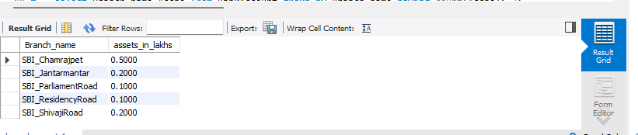

2. CREATE A VIEW WHICH GIVES EACH BRANCH THE SUM OF THE AMOUNT OF ALL THE LOANS AT THE BRANCH.

create view loans(Branch_name,Amount)

as select Branch_name,sum(Amount) from Loan

group by Branch_name;

select * from loans;

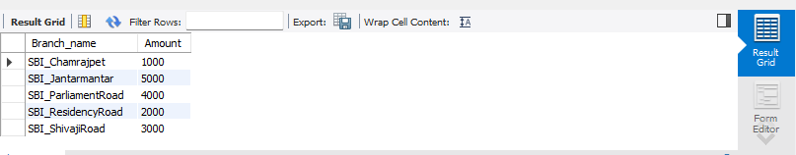

3.Find all the customers who have at least two accounts at the *same* branch (ex. SBI_ResidencyRoad).

select customer_name from depositor where accno in

(select accno from bankAccount where branch_name like '%Resi%')

group by customer_name having count(customer_name)>=2;

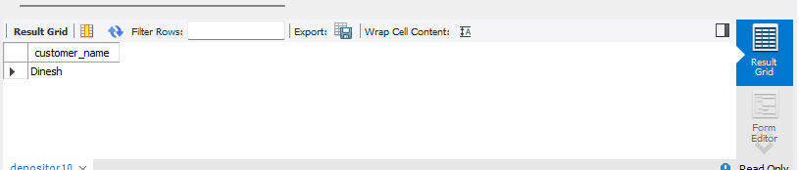

4. Find all the customers who have at least two deposits at the same branch

select customer_name from depositor where accno in

(select accno from bankAccount where branch_name like '%Resi%')

group by customer_name having count(customer_name)>=2;



5.update rs 1000 for the customers residing in bangalore

select CONCAT(Balance+1000,' rupees') UPDATED_BALANCE from bankAccount b, bankCustomer bc, depositor d

where bc.Customer_name=d.Customer_name and b.Accno=d.Accno and bc.city='Bangalore';

